**Project 04 - Girl Develop It (50pts)**

**Content Requirements (10pts)**

* Create a website exactly as it is pictured below and ensure it includes:
  + Logo (download from onCampus)
  + Photos (download from onCampus)
  + “About” section with the pictured writeup
  + List of locations that have working links (e.g. website about the location)
  + Links to social media sites

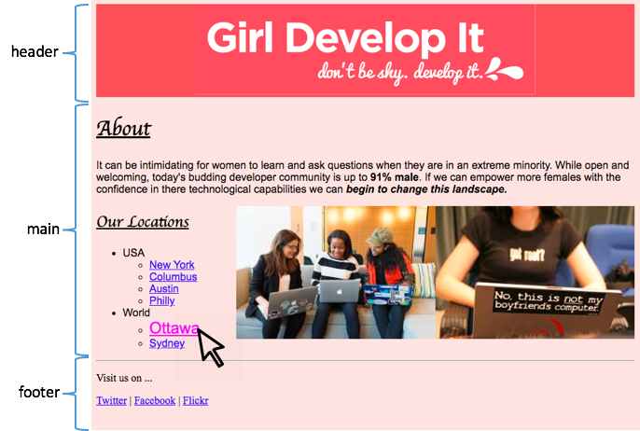

**HTML Requirements (10pts)**

* Use the full structure: <!DOCTYPE html>, <html>, <head>, <title>, <body>
* Put the <body> code into the three layout sections <header>, <main>, and <footer>

**Head Section (10pts)**

* Give your website an appropriate title that corresponds to the content
* You must have all required metadata and ensure that it meets the guidelines discussed in class.
  + Description
  + Keywords
  + *Favicon is optional*
* Properly link your CSS file to your HTML file

**CSS Requirements (10pts)**

* ALL formatting must be done using CSS (including image sizes) with the exception of <i> and <b> for text in the About section.
* Mimic the same font styles for each of the headings as displayed in the image
* Links should appear using the default link style (like above)
* Make the links in the lists change color and get bigger when the mouse hovers over each one (focus too)

**Commenting & Readability (10pts)**

* HTML and CSS files must have:
  + Comments that includes Name, Assignment, and Date
  + Comments about basic info throughout
* Save the files as: **GirlDevIt.html**, **GirlDevIt.css**, **photo-1.jpg**, **photo-2.jpg**,& **logo.png**
* Submit the RawGit link to OnCampus when you’re done